Aggregate Function
1. Count(*)
Count all records from student table.
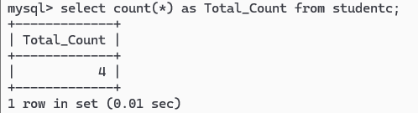

2. Count(col)
Count all records from student table.(Apply the count on s_name)
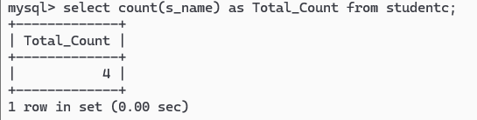

3. Sum(col)
Count the sum of collected fees.
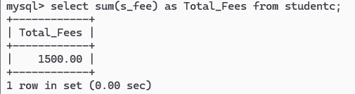

4. Avg(col)
Display the total Average of collected fees.
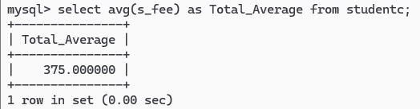

5. Min(col)
Find lowest value of fees paid by the student.
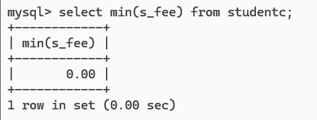

6. Max(col)


